**Session 1: HDFS**

Assignment 1.3

**Student Name**: Karthik K

**Course**: Big Data Engineering with Hadoop & Spark

­

**Task 1:**

Check whether /user/acadgild directory exists or not in the HDFS.

If it doesn't exist, then create this.

Create a directory /user/acadgild/hadoop.

**Solution**: The –mkdir command is used to create the directory.

**Output**:

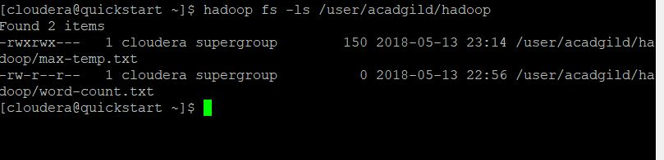

**Task 1 Completed.**

**Task 2:**

Create a file in HDFS under directory /user/acadgild/hadoop, with name word-count.txt.

Whatever we type on screen should get appended to the file.

Try to type (on screen) few lines from any online article or textbook.

**Solution**: The command that is used to append is: “-appendToFile”. When source arg is – it takes the input from the standard Input.

**Output:**

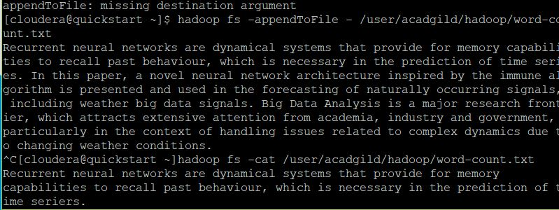

**Task 2 Completed.**